***Ahsanullah University of Science & Technology***

Department of Computer Science & Engineering



Coding Cat

CSE 3224

Information System Design

&

Software Engineering Lab

Submitted By:

Ahmad Subaktagin Jabir 16.02.04.061

Arunima Ayshee 16.02.04.066

Rahat Bin Osman 16.02.04.083

Aniqua Tabassum 16.02.04.085

Date of Submission: **24 September, 2019**

**Introduction:**

Our project, Coding Cat, is an online judge, where it is mandatory to store several crucial data of the users and the programming problems in the database. We have tried to design our database in such a manner that it will not create any redundancy and will not cause any unwanted disaster while manipulating the data within. Additionally, we have tried to make the data retrieval process as efficient as possible.

**Name of the Entities with Primary, Foreign, and Composite keys:**

An entity is any object in the system that we want to model and store information about. Entities are usually recognizable concepts, either concrete or abstract, such as person, places, things, or events which have relevance to the database. Our Project has 12 Entities. They are given below:

1. Talents
2. Portfolio
3. Problems
4. Submission
5. Problem Setter
6. Assessment Test
7. Test History
8. Payment
9. Payment Type
10. Project Manager
11. Search
12. Interview

**Primary and Foreign Key**

|  |  |  |
| --- | --- | --- |
| **Entity** | **Primary Key** | **Foreign Key** |
| Talents | TalentID |  |
| Portfolio | TalentID | TalentID |
| Problems | ProblemID | ProblemSetterID |
| Submission | SubmissionID | TalentID  ProblemID |
| Problem Setter | ProblemSetterID |  |
| Assessment Test | AssessmentTestID | ProblemSetterID |
| Test History | TestHistoryID | AssessmentTestID  TalentID |
| Payment | PaymentID | TestHistoryID  PaymentTypeID |
| Payment Type | PaymentTypeID |  |
| Project Manager | ProjectManagerID |  |
| Search | SearchID | ProjectManagerID  TalentID |
| Interview | InterviewID | SearchID |

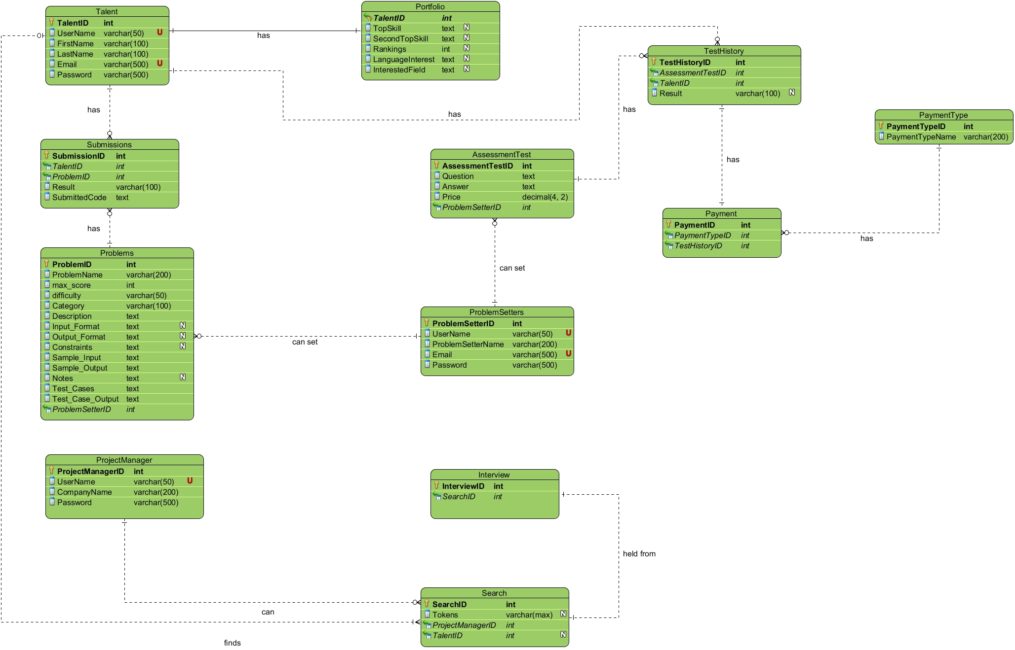**Entity Relationship (ER) Diagram with multiplicity:**

**Talents:**

* Each Talent can have one portfolio. It is a One to One Relationship.
* Each Talent can have many submissions. It is a One to Many Relationship.
* Each Talent can have many Test History. It is a One to Many Relationship.

**Portfolio:**

* One Portfolio belongs to One Talent. It is a One to One Relationship.

**Problems:**

* Many problems can be made by One Problem Setter. It is a Many to One Relationship.
* One problem can have many submissions. It is a One to Many Relationship.

**Submission:**

* Many submissions can be made by a Talent. It is a Many to One Relationship.
* Many submissions can come for a Problem. It is a Many to One Relationship.

**Problem Setter:**

* Each Problem Setter can set many assessment tests. It is a One to Many Relationship.
* Each Problem Setter can set many problems. It is a One to Many Relationship.

**Assessment Test:**

* Each assessment test can have many test histories. It is a One to Many Relationship.
* Many assessment tests can be made by One Problem Setter. It is a Many to One Relationship.

**Test History:**

* Each Test History has a payment. It is a One to One Relationship.

**Payment Type:**

* Each Payment Type can be used many times during Payment. It is a One to Many Relationship.

**Payment:**

* Each payment will be done on the basis of each test History. It is a One to One Relationship.
* A payment type can be used Multiple times. It is a Many to One Relationship.

**Project Manager:**

* Each Project Manager can search many times. It is a One to Many Relationship.

**Search:**

* From every search, there can be one interview. It is a One to One Relationship.

**Interview:**

* Many interviews can be done by a search. It is a Many to One Relationship.

**Relational Model:**

**a) SQL Commands with appropriate relationships and Highlighting Primary & Foreign Key:**

**Talents**

|  |
| --- |
| CREATE TABLE Talents (  TalentID int IDENTITY(1,1) NOT NULL,  UserName varchar(50) NOT NULL UNIQUE,  FirstName varchar(100) NOT NULL,  LastName varchar(100) NOT NULL,  Email varchar(500) NOT NULL UNIQUE,  Password varchar(500) NOT NULL,  **PRIMARY KEY (TalentID)**); |

**Portfolio**

|  |
| --- |
| CREATE TABLE Portfolio (  **TalentID int NOT NULL FOREIGN KEY REFERENCES Talents(TalentID)**,  TopSkill text,  SecondTopSkill text,  Rankings int,  LanguageChoice text,  InterestedField text,  **PRIMARY KEY (TalentID)**); |

**Problems**

|  |
| --- |
| CREATE TABLE Problems (  ProblemID int IDENTITY NOT NULL,  ProblemName varchar(200) NOT NULL,  max_score int NOT NULL,  difficulty varchar(50) NOT NULL,  Category varchar(100) NOT NULL,  Description text NOT NULL,  Input_Format text NULL,  Output_Format text NULL,  Constraints text NULL,  Sample_Input text NOT NULL,  Sample_Output text NOT NULL,  Notes text NULL,  Test_Cases text NOT NULL,  Test_Case_Output text NOT NULL,  **ProblemSetterID int NOT NULL FOREIGN KEY REFERENCES ProblemSetters(ProblemSetterID),**  **PRIMARY KEY (ProblemID)**); |

**Submissions**

|  |
| --- |
| CREATE TABLE Submissions (  SubmissionID int IDENTITY (1,1) NOT NULL,  **TalentID int NOT NULL FOREIGN KEY REFERENCES Talents(TalentID),**  **ProblemID int NOT NULL FOREIGN KEY REFERENCES Problems(ProblemID)**,  Result varchar(100) NOT NULL,  SubmittedCode text NOT NULL,  **PRIMARY KEY (SubmissionID)**); |

**Problem Setters**

|  |
| --- |
| CREATE TABLE ProblemSetters (  ProblemSetterID int IDENTITY(1,1) NOT NULL,  UserName varchar(50) NOT NULL UNIQUE,  ProblemSetterName varchar(400) NOT NULL,  Email varchar(500) NOT NULL UNIQUE,  Password varchar(500) NOT NULL,  **PRIMARY KEY (ProblemSetterID)**); |

**Assessment Test**

|  |
| --- |
| CREATE TABLE AssessmentTest (  AssessmentTestID int IDENTITY(1,1) NOT NULL,  Question text NOT NULL,  Answer text NOT NULL,  Price decimal(4, 2) NOT NULL,  **ProblemSetterID int NOT NULL FOREIGN KEY REFERENCES ProblemSetters(ProblemSetterID)**,  **PRIMARY KEY (AssessmentTestID)**); |

**Test History Table**

|  |
| --- |
| CREATE TABLE TestHistory (  TestHistoryID int IDENTITY(1,1) NOT NULL,  **AssessmentTestID int NOT NULL FOREIGN KEY REFERENCES AssessmentTest(AssessmentTestID),**  **TalentID int NOT NULL FOREIGN KEY REFERENCES Talents(TalentID),**  Result varchar(100),  **PRIMARY KEY (TestHistoryID)**); |

**Payment Type Table**

|  |
| --- |
| CREATE TABLE PaymentType (  PaymentTypeID int IDENTITY(1,1) NOT NULL,  PaymentTypeName varchar(200) NOT NULL,  **PRIMARY KEY (PaymentTypeID)**); |

**Payment Table**

|  |
| --- |
| CREATE TABLE Payment (  PaymentID int IDENTITY(1,1) NOT NULL,  **PaymentTypeID int NOT NULL FOREIGN KEY REFERENCES PaymentType(PaymentTypeID),**  **TestHistoryID int NOT NULL FOREIGN KEY REFERENCES TestHistory(TestHistoryID),**  **PRIMARY KEY (PaymentID)**); |

**Project Manager Table**

|  |
| --- |
| CREATE TABLE ProjectManager (  ProjectManagerID int IDENTITY(1,1) NOT NULL,  Company varchar(300) NOT NULL,  UserName varchar(50) NOT NULL UNIQUE,  Password varchar(500) NOT NULL,  **PRIMARY KEY (ProjectManagerID)**); |

**Search Table**

|  |
| --- |
| CREATE TABLE Search (  SearchID int IDENTITY(1,1) NOT NULL,  Tokens varchar(max),  **ProjectManagerID int NOT NULL FOREIGN KEY REFERENCES ProjectManager(ProjectManagerID),**  **TalentID int NOT NULL FOREIGN KEY REFERENCES Talents(TalentID),**  **PRIMARY KEY (SearchID)**); |

**Interview Table**

|  |
| --- |
| CREATE TABLE interview (  InterviewID int IDENTITY(1,1) NOT NULL,  **SearchID int NOT NULL FOREIGN KEY REFERENCES Search(SearchID),**  **PRIMARY KEY (InterviewID)**); |

**b) Entities with Dummy Data:**

1. **Talent:**

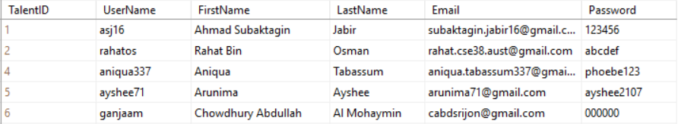

1. **Project Manager:**

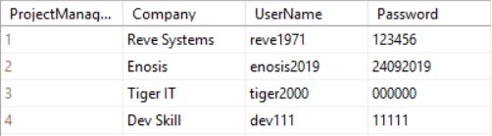

1. **Problem Setters:**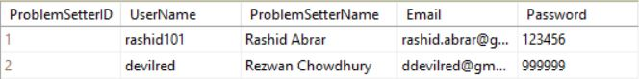
2. **Problems:**



**Designs of Our Project:**

1. **Home Page:** In the homepage, the user will be able to navigate among our various features such as practicing problems or increasing language efficiency, browsing through jobs, participating in coding competitions etc.

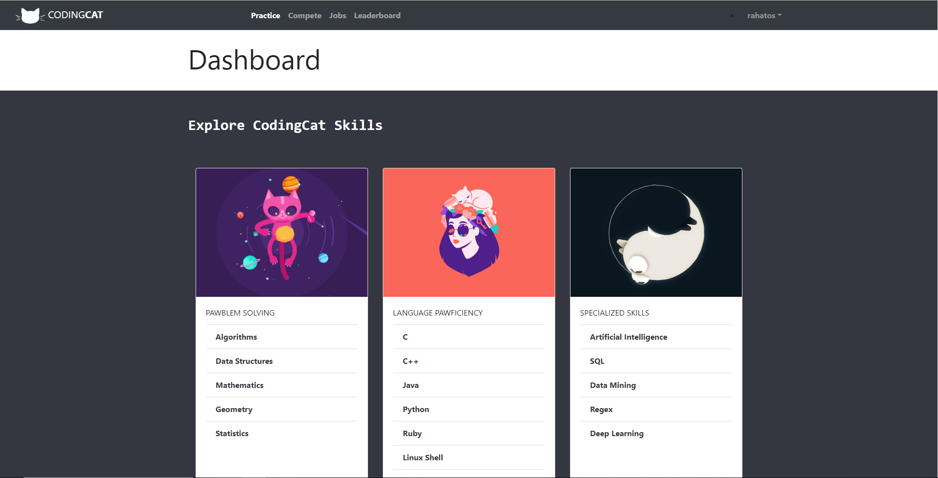

1. **Login Page:** To be able to get access to our features, the registered users must be logged in to our system, and they will be able to log in throughout this login page. The login process will require users to enter the unique username with which they registered into the system and the corresponding password. If the user is not a registered into our system, then s/he can go to the "register" link placed in the bottom right of the box and get themselves registered.

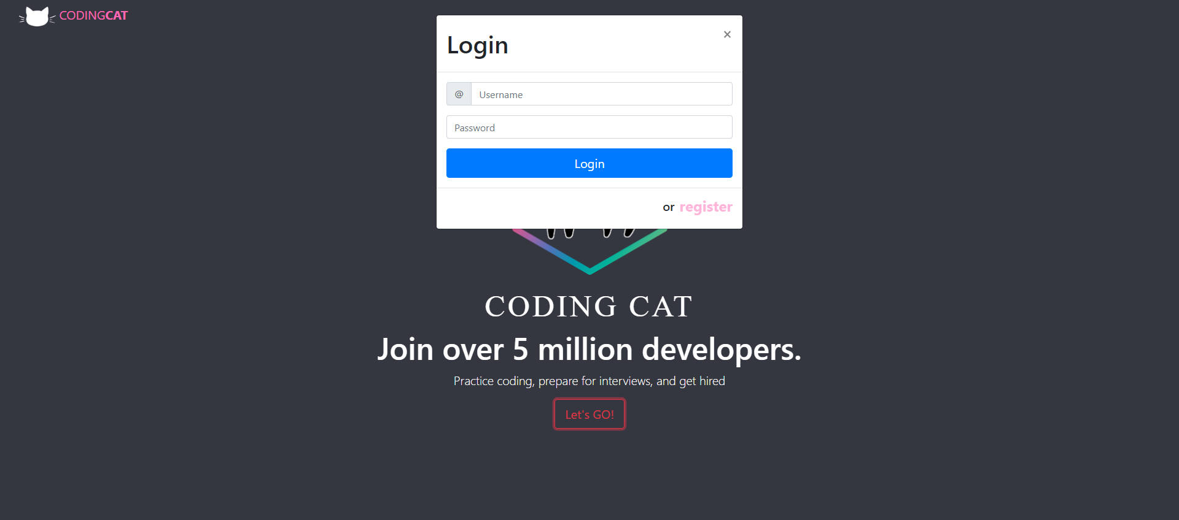

1. **Registration Page:** Unregistered users must register first to be a part of the system. For that purpose, we have designed this page. The registration process will be completed by taking a few information from the user, such as the username by which they will be recognized in our system, email ID, first name, last name and password. This password will be converted into a hashcode before being saved into the database.

If the user is already registered in our system, then s/he can navigate to the login page using the link provided in the bottom right of the box.

In our report on Functional and Non-functional report on Coding Cat, we had mentioned that it will not take more than 120 seconds for a new user to register. We have designed the signup page accordingly.

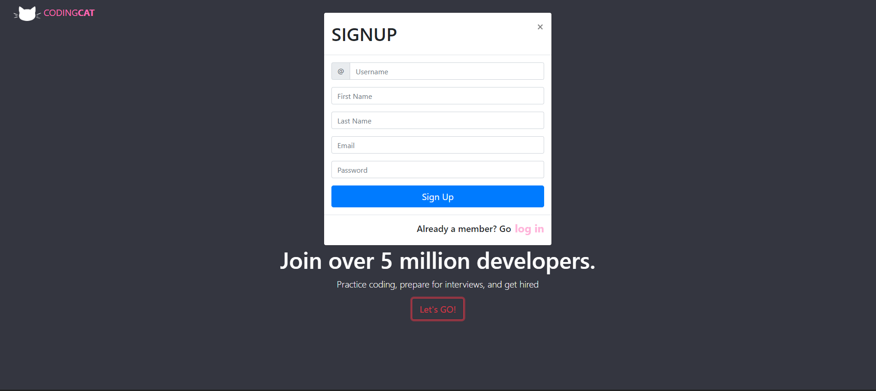

1. **Practice Problems Page:**

In the Practice Problem page, users will be able to browse through any branch of computer science and solve any problem they like. The name of the problem will be on the left of every row, as mentioned below, and a button will be placed on the right that will navigate them to the problem page, where they will see the complete problem statement and will be able to submit their codes. The difficulty level and maximum score of the problems will also be mentioned under the name of the problem.

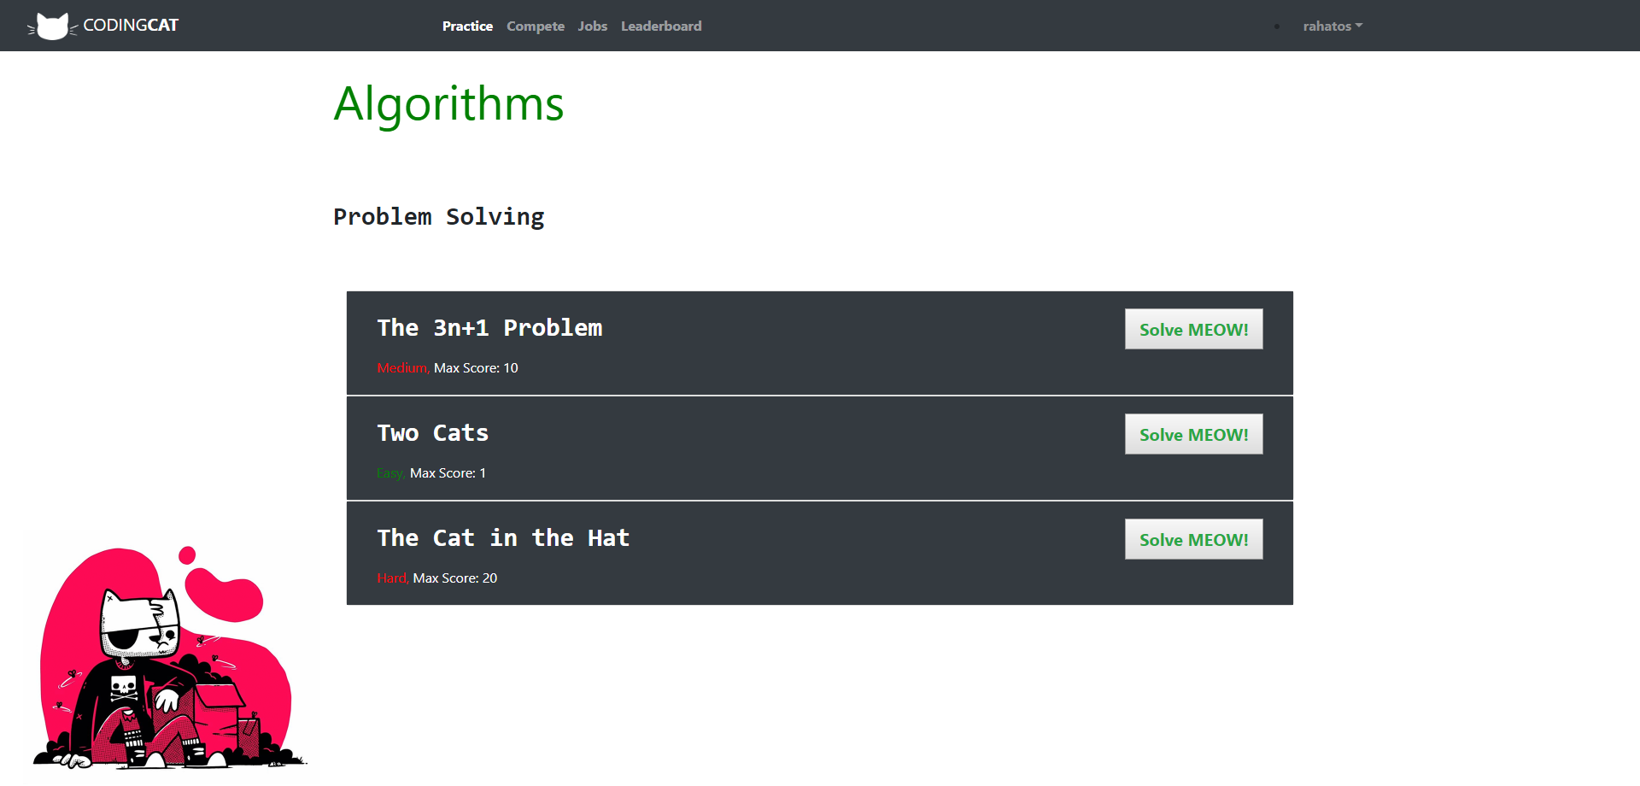

1. **Problem Page:**

This is the page where users will see the full problem statement of the problem they decided to give a try. The name of the problem will be mentioned on the top of this page, along with its difficulty level. Right below that, users will be given options to navigate to their submission history, dashboard and leader board of this problem. Next will come the complete problem statement, where the programming problem will be discussed at length. After that, input and output format, sample input and output will be displayed in respective orders. If the problem setter mentions some constraints for a problem, that will be mentioned in this page too.

In this page, users will be able to submit their code as well, and get the verdict. This feature has been placed below the sample output, after the complete description of a problem ends.

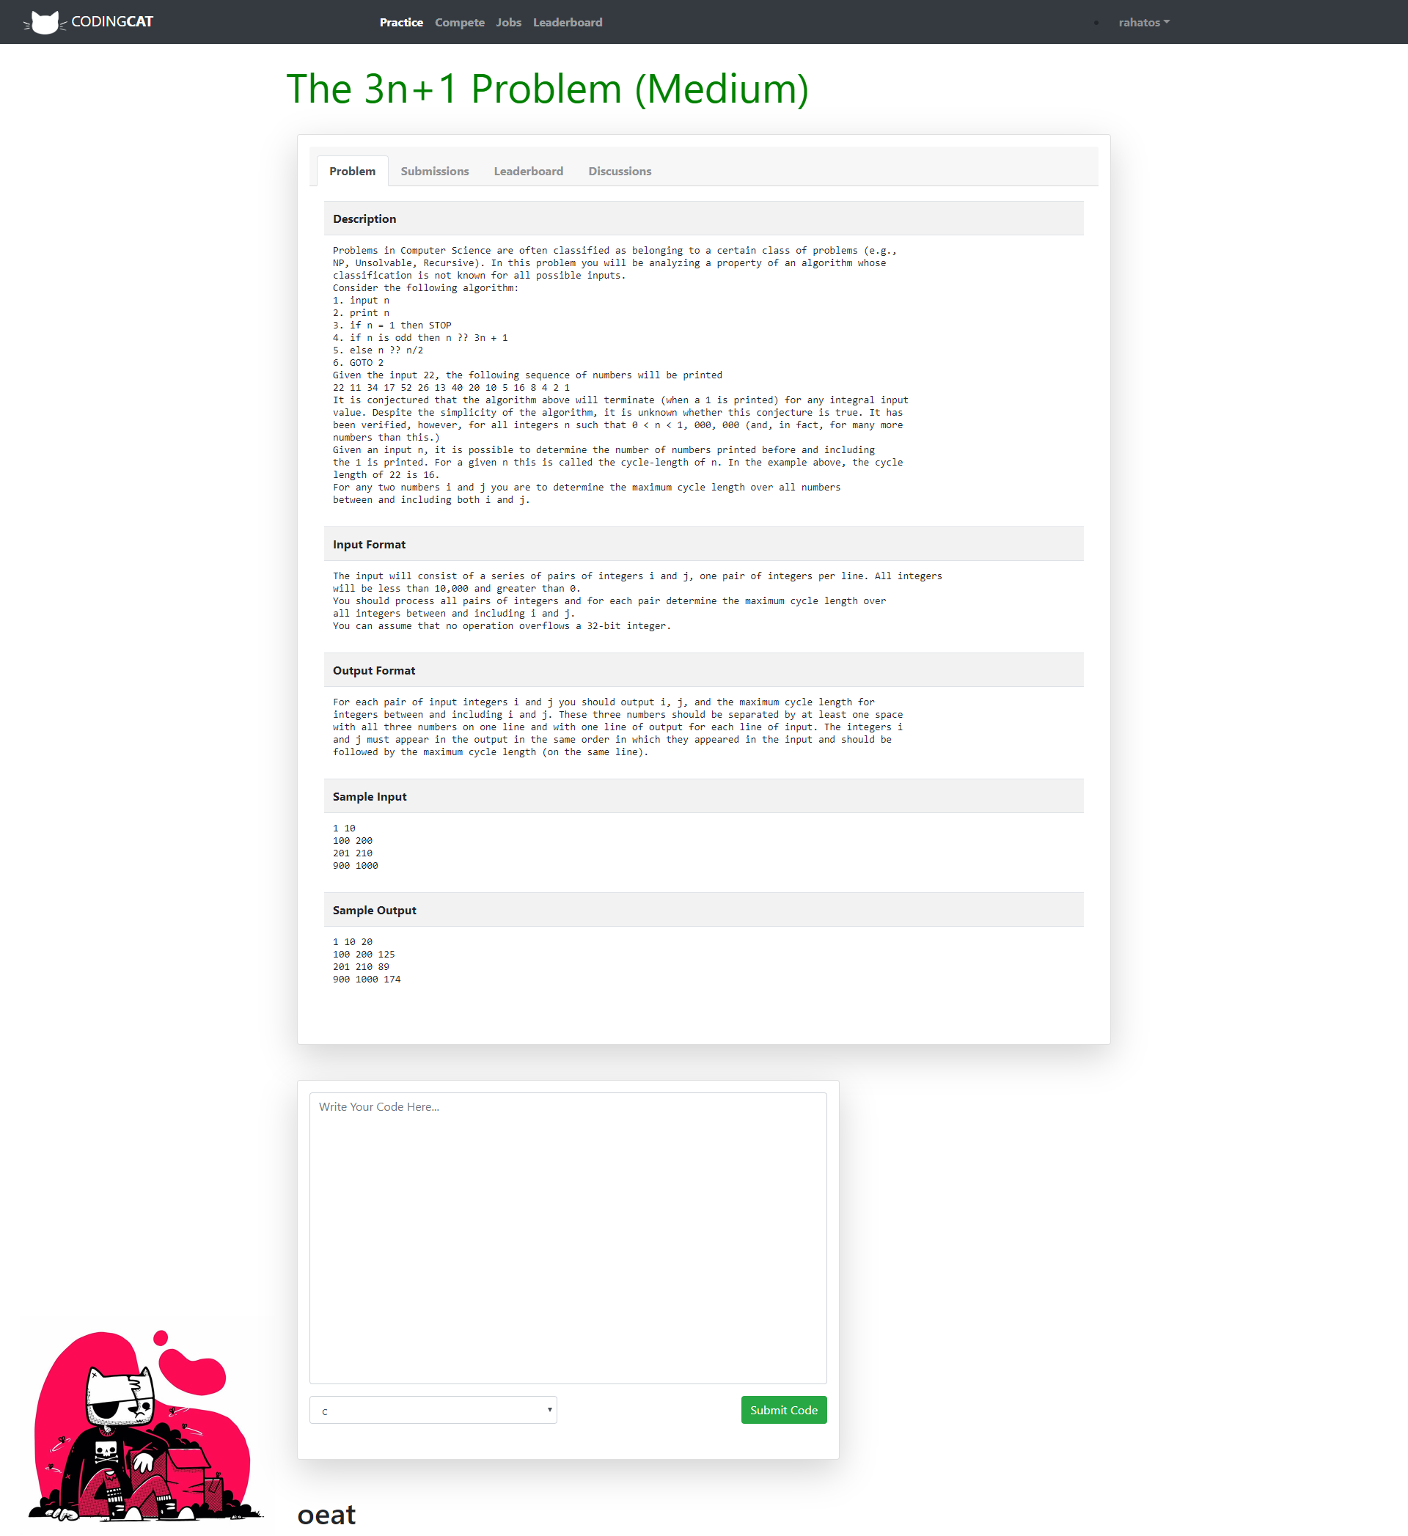

**Conclusion:**

The necessity of an attractive and user-friendly user interface, along with an efficient and rich database cannot be denied while making a system nowadays. We have tried our best to design our website in such a way that the user gets the best experience and their useful data gets stored in our database in the most efficient manner, which will help us improve the user experience even more in the advanced development phases. We hope that our work so far is sufficient to fulfill our goals so far, although we are still trying relentlessly to improve and renovate our system to provide our users with the top-class experience. It is our humble request to see any mistakes of ours in the eyes of forgiveness.